8-2 and 8-3 Recitation Activity

S-Z p. 637 8.7:

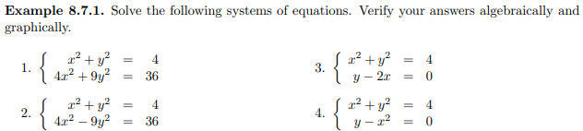

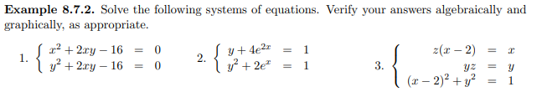

S-Z 8.7.1 HW #15  #17; 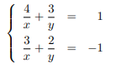

S-Z 8.7.1 HW

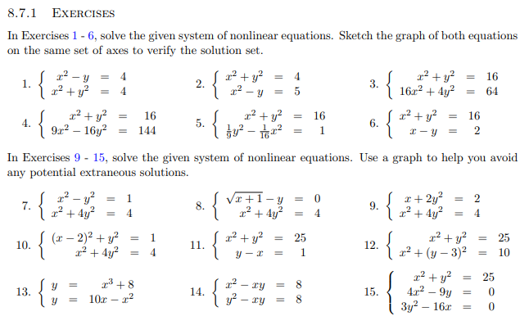



S-Z 8.7 HW



1. Calc-Medic 6.1; I’m thinking of a pair of mystery numbers, *x* and *y*. Squaring the x-value gives you a number that is 5 more than the y-value. Can you find a pair of numbers that would work? How many such pairs are there?
2. Send one person to the board to plot two of the ordered pairs $(x,y)$ that your group came up with using **red** dot stickers. Then copy down all the class dots on the coordinate grid below.

1. What does each dot represent?
2. What do you notice about the shape made by all the dots?
3. Now I’m thinking of another pair of mystery numbers. The difference between double the $x$-value and the $y$*-*value is negative 3. Can you find a pair of numbers that would work? How many such pairs are there?

Calc-Medic: 6.2; .

11.

10. If is a solution of the system of equations above and $y>0$, what is the value of $y$?

Calc-Medic 6.2: 9. The tide removes sand from Sandy Point Beach at a rate modeled by the function R, given by

$$R\left(t\right)=2+5\sin\left(\frac{4πt}{25}\right)$$

A pumping station adds sand to the beach at a rate modeled by the function S, given by

$$S\left(t\right)=\frac{15t}{1+3t}$$

Both $R(t)$ and $S(t)$ are measured in cubic yards per hour. At what instant, *t*, is the amount of sand not changing?

Calc-Medic 6.2: 5. A community garden is being built in a neighborhood. The length of the garden is to be 6 feet longer than the width. If the area of the garden will be 112 square feet, what will be the length, in feet, of the garden?

**8-3: Need applications with extraneous variables as well as like related rates/optimization. Look at 1151/2167 sections.**

From Briggs:

Given area, perimeter of rectangle/fence/divided garden

Postal problem. Length + girth < 108.

Point on graph closest to given point

Oil rig/walk and swim

Rectangle beneath parabola/semicircle.

Max volume of cone cut from circle

Garden and path around it.

Silo: Metal dome on top of cylinder: Cost of metal = 1.5 times cost of concrete.

Fix volume or SA max/min other

Cylinder in cone, rectangle in triangle.

Wire length cut into two pieces to make square and circle. Max/min area, length.

Have a box. Find 3 boxes with a volume of 9. Now consider only those boxes with the length = twice the width. List 3 of those boxes with a volume of 9. Now assume that not only the restriction of l = 2w is true, but the height is 5 times the width. Find 3 such boxes with volume 9.